Bribery & Fraud
Risk Awareness Toolkit

Issue 1 – 15 Apr 2013

Jonathan Silk

University of Oxford – Council Secretariat

DOCUMENT VERSION
This document is Issue 1, published in Apr 2013. Ensure that you are using the current version – any previous versions of this document should be discarded as information contained therein may be out of date.
DOCUMENT HISTORY
The following issues of this document have been produced to date:
Issue / Version | Author | Date | Reason for issue
Issue 1 | Jonathan Silk | 15-Apr-2013 | Initial issue

CONTACT DETAILS
This document is produced and controlled by the Senior Assistant Registrar (Anti-Bribery and Risk Management). If you have any feedback or queries on the detail then please contact:
Contact | Telephone | E-Mail
Jonathan Silk | (2) 70187 | Jonathan.Silk@admin.ox.ac.uk

CONTENTS

1. Introduction 3
1.1 Purpose of this document: 3
1.2 Arrangement and summary of tools provided: 3
2. Defining the subject matter 4
2.1 Objectives and plans: 4
2.2 Activity analysis: 5
2.3 Relationship analysis: 6
3. Assessment and control of risk 7
3.1 Bribery and fraud risk assessment: 7
3.2 Due diligence: 7
4. Warning Indicators 8
4.1 Key factors influencing bribery and fraud: 8
4.1 Warning signs: 9
Appendix 1 – Activity Analysis full diagram 10
Appendix 2 – Relationship Analysis Full diagram 11
Appendix 3 – Risk Assessment questionnaire 12
Appendix 4 – Due diligence considerations 17
Appendix 5 – SFO Warning indicators 19

1. Introduction

1.1 Purpose of this document:
1.1.1 This document provides a framework for considering bribery and fraud risk within the University and assessing, in particular, whether an activity is subject to heightened exposure. Where this is the case, consideration is also given to controls that might mitigate the risk.
1.1.2 Use of these tools is not mandatory, since not all will be applicable for every department. Departments are encouraged to apply those that are relevant, however, as elements of recommended good practice.

1.2 Arrangement and summary of tools provided:
1.2.1 The following topics are addressed:
(a) Defining the subject matter
Risk relates to the threats or opportunities that may affect the activities undertaken by a department in seeking to achieve objectives. Activity analysis and relationship analysis are tools that help understand what a department’s key objectives, main activities and relationships are, and how they might be affected by risk.
(b) Assessment and control of risk
A questionnaire-based bribery and fraud risk assessment is provided to help determine where areas of increased risk might lie. This also includes suggested mitigating controls and a quick means of determining progress in addressing risk.
In addition guidance is provided on due diligence that might be undertaken to assess the inherent risks of new relationships with suppliers, partners, collaborators, customers, etc.
(c) Warning indicators
A brief outline of some of the key factors that need to be in place for bribery or fraud to occur is provided together with a set of warning signs - indicators of potential corruption. The intention is to help departments understand where weak points might lie and spot behaviour which may be indicative of underlying problems.
1.2.2 The toolkit may be used, in whole or in part, at any level of the organization: within departments, sub-departments, sections or groups; or applied specifically to single, large transactions such as major projects.

2. Defining the subject matter

2.1 Objectives and plans:
2.1.1 In order to identify, assess and control bribery and fraud risk successfully (or any risk for that matter), it is necessary to begin with some understanding of the subject matter, i.e. the organization (or part thereof) under consideration.
2.1.2 Risk may be defined as the threats and opportunities that affect the achievement of objectives. If you can readily identify the objectives and the activities that are undertaken to achieve those objectives, therefore, you have a sound starting point for assessing associated risk.
2.1.3 Objectives may be defined in statements, strategies, plans or equivalent documents. It should be possible to list the main objectives of any organization or part – if not, then there is the potentially wider risk issue of there being a lack of clarity concerning objectives (which is beyond the remit of this toolkit but should be addressed as a matter of urgency).
2.1.4 Hand in hand with objectives there should ideally be some kind of plan – whether this is called a ‘plan’, a ‘strategy’ or anything else. In simple terms a plan should outline how it is intended to achieve the stated objectives. The key to a good plan, however, is that it should be ‘SMART’ – stating how objectives will be achieved in a manner that is:
Specific | Defines with precision the activities to be undertaken, the resources to be used, the funding, etc. What needs to be achieved, why, who is involved, etc.
Measurable | Uses objective measures so that it can be readily determined when an objective has been achieved and what progress has been made.
Achievable | Ensures that goals should be realistic and attainable, considering limitations on available resources, competing demands, etc.
Relevant | Addresses the right issues at the right time – ensuring that plans are prioritized in the most efficient and effective manner.
Timely | Places goals and outputs into a definite timeframe, with deadlines to ensure that there is accountability for delivery at appropriate points.

2.1.5 If all of the above elements are in place then it should be a straightforward matter to define the key objectives and main activities. If the picture is unclear, or the information is imperfect or incomplete, however, then the following tools will help identify the activities that are undertaken and where some of the risks lie in respect of interaction with third parties.

2.2 Activity analysis:
2.2.1 Whether or not the activities of a department or unit are clearly defined in a plan or strategy document, there may be some merit in mapping what actually happens (as opposed to what is stated to happen). The following diagram summarizes how a unit, department or whole organization might be split for the purposes of this exercise:
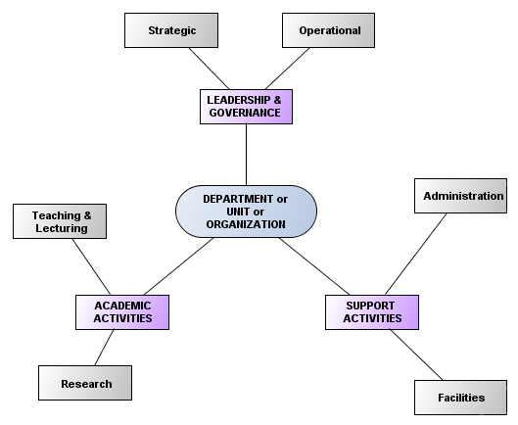

Appendix 1 sets out how each of these are analysed further.
2.2.2 Using this generic map (not all of which will necessarily be applicable to all subjects) as a starting point, it should be possible to define and list the distinct activities that take place within a unit, department or organization:
(a) Academic activities – what are the distinct course, programmes, research groups or clusters?
(b) Support activities – what administrative and support functions (including any IT and facilities management) are there?
(c) Leadership and governance – what is the management hierarchy and what the governance hierarchy (these may be one and the same, or there may be differences between management teams and committees or boards)?
2.2.3 The end result of the activity analysis exercise should be a diagram, similar to the one in Appendix 1, against which it is possible to identify or map all the main activities of the unit, department or organization under consideration.

2.3 Relationship analysis:
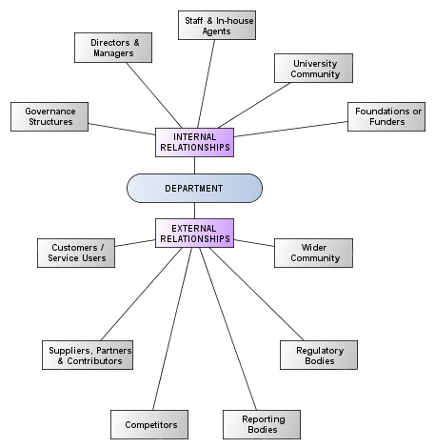
2.3.1 Relationship analysis identifies and considers the interaction the activities of a unit, department, or organization have with people and organizations. As bribery and fraud are essentially transactional risks that occur around these interactions an understanding of those relationships is also a good starting point for risk assessment. The following diagram summarizes a generic view that is further analysed in Appendix 2:

2.3.2 From a bribery and fraud perspective, particular relationships to pay attention to are:
(a) Internal – use of in-house agents, ‘associates’, consultants and similar.
(b) External – any corporate customers or service users, suppliers, partners and collaborators. In certain circumstances it may also be appropriate to consider competitors and whether there is any risk associated with gaining, losing or maintaining competitive advantage.
2.3.3 Using this generic map (not all of which will necessarily be applicable to all subjects) as a starting point, it should be possible to define and list the main relationships arising from the activities of a unit, department or organization.
2.3.4 The end result of the relationship analysis exercise should be a diagram, similar to the one in Appendix 2, against which it is possible to identify or map all the main relationships the unit, department or organization has with people or other organizations.

3. Assessment and control of risk

3.1 Bribery and fraud risk assessment:
3.1.1 Armed with knowledge of the unit, department or organization under consideration, it should be possible to carry out a bribery and fraud risk assessment with the purpose of understanding whether there are any particular areas that are of heightened risk.
3.1.2 A questionnaire is provided at Appendix 3 to facilitate this. It is split into three parts:
(a) The nature of the activity;
(b) The location of the activity;
(c) The relationship with third parties.
This questionnaire can be used against each separately identified activity within a unit, department or organization, or it can be used against single large or complex activities (such as major projects, purchases or sales). It is generally not possible to use the questionnaire effectively on the unit, department or organization as a whole since this is likely to be too broad an assessment to provide meaningful results.
3.1.3 In addition to facilitating the identification of risk factors, the questionnaire also provides an assessment of possible mitigating controls. This can be used in a number of ways: as a means of confirming that controls are already in place for the identified risks; as a means of measuring progress towards introduction of controls; or as a means of identifying potential controls where none already exist in whole or in part.
3.1.4 There are two key points to recognize in respect of controls:
Adequacy | They should be sufficient to do the job intended
Proportionality | They should be in proportion to the scale of the risk involved
The second is easy to overlook, but if the risk is relatively small then an onerous or complex control may be adequate but totally disproportionate as a response.
3.1.5 The questionnaire is kept relative simple and straightforward since it is not possible to determine with any degree of mathematical precision the risk of bribery or fraud materializing. Instead, the intention is to provide a starting point for consideration of the potential risks and a means of focussing on how those risks might be addressed. Further help in this is also provided in section 4, ‘Warning Indicators’.

3.2 Due diligence:
3.2.1 When considering new relationships with third parties the question of ‘due diligence’ may arise – i.e. the necessary checks to ensure that the third party in question is bona fide and free from the risk of association with bribery and fraud. Using a supplier who in turn may use practices that are corrupt or illegal, for example, is not only embarrassing by association but, depending upon the nature of the relationship, could result in the University being prosecuted for not preventing bribery or for having inadequate procedures.
3.2.2 Appendix 4 provides a checklist, therefore, of broadly generic considerations that may help. In most cases due diligence is only required when considering other organizations and where a significant, strategic or long-term relationship is envisaged. The principles apply equally to individuals, however, so if there is any heightened risk around such relationships (e.g. agents or consultants) then consideration should be given to applying the checklist also, in whole or in part.

4. Warning Indicators

4.1 Key factors influencing bribery and fraud:
4.1.1 This section outlines three key factors that need to be present for bribery or fraud to occur:
(a) Motive;
(b) Means; and
(c) Opportunity.
Being aware of these does not in itself prevent corruption but provides tighter focus to considerations of risk, proportionate response, appropriate controls, etc.
Motive – why would they do it?
4.1.2 Bribery and fraud require a motive, whether that be to obtain an advantage or gain for the perpetrator (or their associates), or to cause a disadvantage or loss, usually for the subject organization. The reasons for doing this may be many and varied but can include:
Possible reasons for corruption:
- financial difficulties or pressures on individuals or organizations;
- social, domestic or other problems in an individual’s personal life;
- the desire to obtain or retain standing or reputation;
- opportunistic greed (i.e. simply because the opportunity presents itself);
- radical or contentious belief systems;
- redress for an actual or perceived wrong done to the perpetrator;
- duress or coercion (i.e. being forced into an activity against the individual’s will).

4.1.3 Equally, consider that the greater the potential reward, the greater the possible motive. Generally, University activities might be considered to have relatively low financial gain or reward when compared with some sectors of commerce or industry, but equally the open and devolved nature of the organization makes it more difficult to guard against (and thereby potentially easier to commit) bribery and fraud. Reward may take many forms, including:
Perceived rewards of corruption:
- financial or monetary gain;
- ownership of, access to, or usage of property (whether physical or intellectual);
- enhancement of reputation, standing or favour;
- depriving the subject individual or organization of any of the above, or causing any other loss

Means – what would they do?
4.1.4 As outlined above, reward may be financial or non-monetary. Depending upon its nature, consider what might be the methods of obtaining that reward. Consider also that whereas fraud is generally committed in one direction (i.e. finances, assets, etc. are acquired or moved out of the target organization by the perpetrator) bribery is generally bi-directional (i.e. a bribe is paid in one direction in order to facilitate a greater benefit in the other).
4.1.5 Possible means by which bribery and fraud can be effected include:
Bribery methods: | Means of effecting fraud:
- hidden payments (‘brown envelopes’);  - legitimate payments for illegitimate reasons;  - unwarranted gifts, property, hospitality, etc.  - provision of position or enhanced standing;  - preferential treatment or advancement;  - sexual favour, blackmail or duress. | - un-monitored or un-recorded transactions (both low volume/high value and vice versa);  - individuals given too much authority (lack of division of responsibility and counter-check);  - exploitation of weak system controls;  - collusion or ‘insider knowledge’.

4.1.6 Certain positions or activities require a greater degree of trust to be placed on individuals, be that due to the handling of money, sensitive or key data, or due to the decision-making responsibilities involved. Trust should not be relied upon solely, however, since its exploitation is often at the heart of corruption cases. An adequate and proportionate counter-balance of control – division of responsibilities, for example, or scrutiny and oversight – should always also be employed, as much for the protection of the individuals concerned as for the organization.
Opportunity – how, when or where might it be done?
4.1.7 Consideration of opportunity is consideration of how activities, relationships, motives, and means combine and, specifically, when or where weak points might arise for individuals or organizations with corrupt motives to exploit them.
4.1.8 Many controls work on the basis of reducing or removing opportunity by limiting means, ensuring the regular review of activities and individuals involved, and understanding both the relationship with third parties and the nature of the third parties themselves. For example, a supplier taking part in a procurement tendering exercise might seek to influence the decision through offering gifts and hospitality to the University staff involved. It is forbidden, therefore, under the University’s Gifts and Hospitality Policy, to accept gifts or hospitality from suppliers at such times.

4.1 Warning signs:
4.1.1 Bribery and fraud, by their nature, tend to be hidden and not carried out in plain view. Detection, therefore, is often difficult since the direct signs (unexpected losses or expenditure in financial statements, the award of contracts or positions to family, friends, etc.) are often covered up or explained away.
4.1.2 Corruption is often discovered, either through the actions of a ‘whistleblower’ (someone who is aware of what is occurring and chooses to report it rather than condone it), or through being alert to the indirect signs of its existence.
4.1.3 The University has a Code of Practice on Public Interest Disclosure under which any concerns about malpractice or impropriety may be made. The interests of the individual making the disclosure are protected under this Code and under law so that they cannot be dismissed, penalized or disadvantaged as a result of making such a disclosure. Further information on the Code is available at:
http://www.admin.ox.ac.uk/personnel/cops/pid/
4.1.4 The indirect signs of corruption require departments and individuals to be alert to how activity is being conducted around them – and what opportunities for corruption might exist as a result. Appendix 5 provides a checklist, produced by the Serious Fraud Office, that can help identify behaviour that may be indicative of underlying issues.

Appendix 1 – Activity Analysis full diagram
The following diagram provides a more detailed generic analysis of the types of activity that might be relevant to a department of the University:
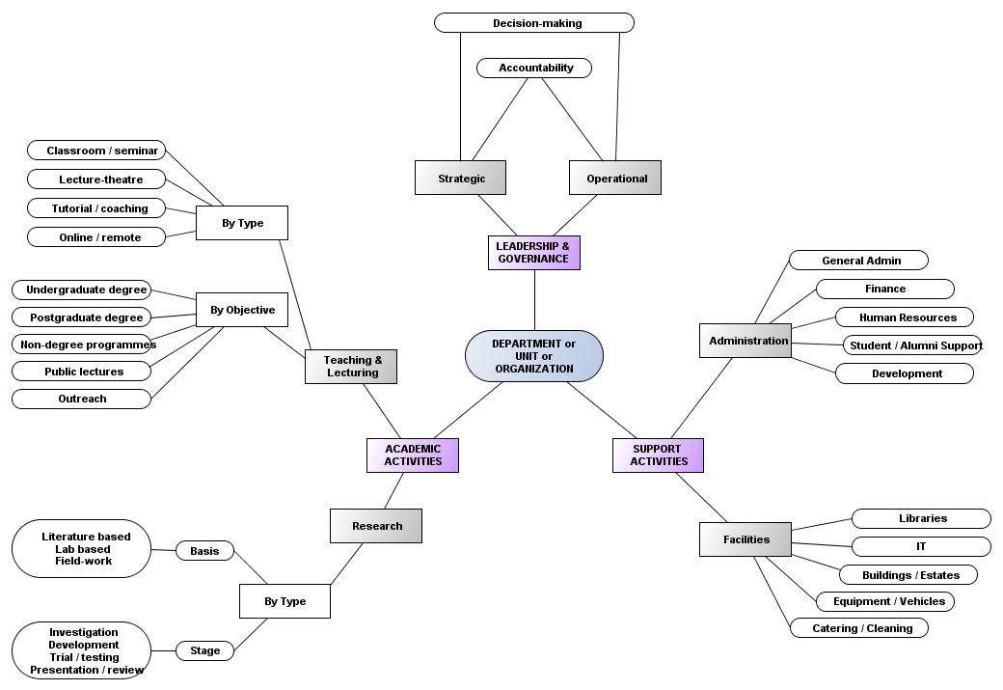

Some (e.g. ‘Teaching and lecturing’ and ‘Research’) may be analysed in different ways – i.e. by type, objective, basis or stage. The most suitable method will vary from department to department, depending upon the nature of activities undertaken and how they are grouped or managed.

Appendix 2 – Relationship Analysis Full diagram
The following diagram provides a more detailed generic analysis of the types of relationship that might be relevant to a department of the University:
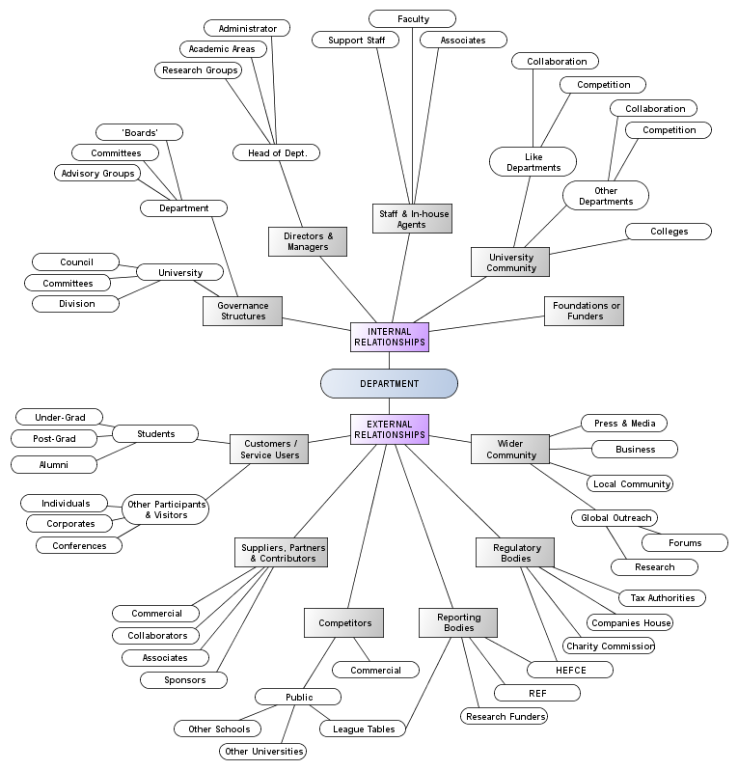

Appendix 3 – Risk Assessment questionnaire
A. The nature of the activity
(i) Context:
Generally, University activities should be at low risk of corruption: the potential rewards being less than in some areas of commerce or industry. Specifically, however, there are areas of potential raised risk – so consider the activity in question within the context of the following elements.

(ii) Increased risk factors:
The following factors increase risk in respect of the nature of the activity under consideration. Place a tick against all those that apply:
Indication of whether this risk applies: | Tick
(a) Major purchases – dealing with major acquisitions, purchases and tenders (over £100k), including property, equipment, IT, etc.
(b) Major sales – dealing with sales over £100k, including business development and pursuit of targets, negotiations, and contracts.
(c) Donations – dealing with philanthropic and commercial donors and sponsors, actual and potential (i.e. excluding regular research grant sponsors).
(d) Recruitment & admissions – of staff or students, where this is a significant part (exceeding 20%) of the activity under consideration.
(e) Division of responsibilities – are decisions or actions in any of the above areas taken by single trusted individuals without additional check or supervision?

(iii) Mitigating controls:
University policy and procedures guard against general risk. Consider also the following controls as a means of further mitigating the factors identified above. Use the ‘level of implementation’ boxes to indicate whether such controls are already in use (in full or in part), or otherwise.
Level of implementation: | None | Part | Full
(a) Training and awareness – both those responsible for running the activity and all staff who undertake the activity should have received bribery awareness training and have access to reference material (full implementation).
(If only directors and managers, or staff undertaking the activity, or not all in either case have received the training then show partial implementation,)
(b) Procedural controls – all processes and controls within the activity are documented, up to date and regularly reviewed, ideally with audit sign-off (full implementation).
(If processes are documented in part, are not up to date or regularly reviewed, then show partial implementation.)
(c) Control of opportunity – either: no staff involved in the management or provision of the activity are permitted to receive gifts or hospitality from third parties; or ALL instances of gifts and hospitality received are formally recorded (full implementation);
(If the receipt of gifts and hospitality is permitted but only those items recorded that are required as the minimum under University rules, then show partial implementation.)
(d) Division of responsibilities – where this is an issue, ensuring that the areas at risk are split between at least two individuals and/or key decisions are reviewed and counter-signed by a line manager or supervisor.

B. The location of the activity
(i) Context:
The majority of University activities that are undertaken within Oxford or the UK should be at low risk of corruption. Some activities may be performed overseas, however, in whole or in part, and some in territories where corruption is a greater endemic risk.

(ii) Inherent risk:
The attached table shows the Corruption Perceptions Index, an exercise that measures perceived levels of public sector corruption globally (and by proxy may be taken as a reflection of wider cultural attitudes within the countries concerned). It is compiled annually by Transparency International – www.transparency.org Consider where the activity in question takes place or is delivered, and whether staff are engaged there long-term or only on short-term visits.
Indication of whether this risk applies: | Tick
(a) High risk – long-term engagement (over 12 months) or frequent short-term visits to territories rated with a score lower than 50 on the TI Corruption Perceptions Index.
(b) Medium risk – occasional short-term visits to territories that are rated with a score lower than 50 on the TI Corruption Perceptions Index.
(c) Medium risk – long-term engagement or frequent short-term visits to territories that are rated with a score of 50 to 69 (inclusive) on the TI Corruption Perceptions Index.

(iii) Mitigating controls:
University policy and procedures guard against general risk. Consider also the following controls as a means of further reducing the inherent risk identified above. Use the ‘level of implementation’ boxes to indicate whether such controls are already in use (in full or in part), or otherwise.
Level of implementation: | None | Part | Full
(a) Training and awareness – country-specific guidance and bribery awareness training for both those responsible for running the activity and all staff who undertake the activity, with access to guidance and reference material (full implementation).
(If only some staff have received the training, or the guidance provided has been generic rather than country-specific, then show partial implementation,)
(b) Procurement controls – either: all purchases are made within the UK; or all purchases over £5k are made in the UK, whether or not in either case they are subsequently shipped to the country in question (full implementation).
(If standard University purchasing processes and reimbursement of expenditure are applied without the additional measures outlined above, then show partial implementation.)
(c) Cash and income control – all sales or income relating to the activity are handled within the UK / there are no sales or income (full implementation).
(If sales and income are handled in-country to fully documented procedures then show partial implementation.)
(d) Recruitment control – all recruitment of staff or workers on the activity is handled within the UK / there is no staff recruitment involved (full implementation).
(If recruitment is handled in-country, but to fully documented processes that involve University-trained staff, then show partial implementation.)

C. The relationship with third parties
(i) Context:
For corruption to occur the normal relationship with third parties (suppliers, customers, students, etc.) needs to be subverted in some way. Certain types of relationship are at higher risk than others, due to the practices of the sectors in which they operate, the availability of means to enable corruption, or the potential rewards at stake.

(ii) Increased risk factors:
The following factors increase risk in respect of relationships with third parties. Place a tick against all those that apply:
Indication of whether this risk applies: | Tick
(a) Use of agents, partners or associates – intermediaries acting with or on behalf of the University in any capacity (including joint ventures), but particularly in an overseas context.
(b) Origin – irrespective of where the activity is delivered, the territories from which third parties (students, suppliers, partners, customers, etc.) originate may increase risk, particularly if the main or majority relationship is with individuals or organizations that originate in those territories identified as ‘High Risk’ under section ‘B’ above.
(c) Reputation – if the reputation or past track record of a third party shows a likelihood for bribery or corruption then this increases risk.
(d) Construction industry / land & property purchases – as a sector, is subject to heightened risk of bribery and corruption.
(e) Public officials – there is heightened risk if there is a significant need to deal with public officials or politicians as part of the activity; more so if they originate from territories identified as ‘High Risk’ under section ‘B’ above.
(f) Licences – where there is a particular need for licences, approvals, visas, etc. to be granted by authorities (particularly when dealing overseas).
(g) Pressure sales – particularly with a ‘trophy’ name such as Oxford University, some suppliers (or potential students or applicants) may resort to underhand tactics in order to close a deal; consider whether this is a likely risk.
(h) Complex relationships – multi-stranded relationships (e.g. where a supplier is also a donor; or where a project deals with multiple sub-contractors) should be individually identified as potential sources of heightened risk.

(iii) Mitigating controls:
University policy and procedures guard against the general risk. Consider also the following controls as a means of further mitigating the risk factors identified above. Use the ‘level of implementation’ boxes to indicate whether such controls are already in use (in full or in part), or otherwise:
Level of implementation: | None | Part | Full
(a) Training and awareness – as with the previous areas, training of both those responsible for running the activity and all staff who undertake the activity should be a priority, with particular emphasis on the risk factors identified (full implementation).
(If only directors and managers, or staff undertaking the activity, or not all in either case have received the training then show partial implementation,)
(b) Due diligence – comprehensive background checks are performed and formally recorded on all significant third parties prior to engagement (full implementation).
(If partial checks are performed then show partial implementation.)
Further guidance on due diligence checks is provided at Appendix 2.
(c) Contractual controls – all relationships with third parties are subject to contracts or similar agreements that include the University’s approved wording on bribery (full implementation).
(If only some agreements meet this standard then show partial implementation.)
Consider also the jurisdiction under which contracts are agreed, with preference in most cases for English Law – if in doubt, seek further advice from University Legal Services.
(d) Communication – third parties, particularly agents, have received clear guidance on the University’s Anti Bribery requirements and have provided signed acknowledgement of their obligations (full implementation).
(If communication is provided but no acknowledgement obtained, then show partial compliance).

Corruption Perceptions Index
The following table is provided by Transparency International, a global not for profit organization whose stated aim is to stop corruption and promote transparency, accountability and integrity at all levels and across all sectors of society – www.transparency.org
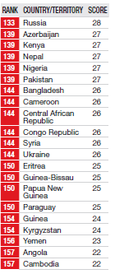
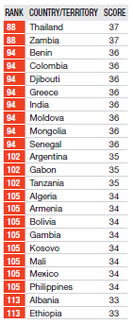
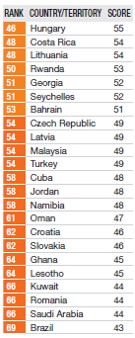
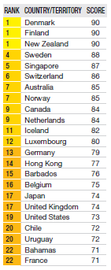
This table, published in December 2012, shows perceived levels of public sector corruption, ranked by country on a global basis – the least corrupt territories are ranked ‘1’ and the lower the score (out of 100), the more corrupt the country in question is.

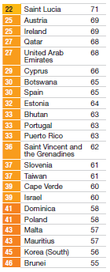
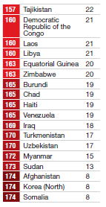
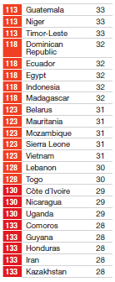
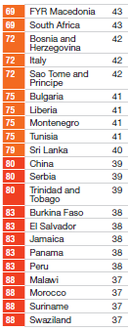

Appendix 4 – Due diligence considerations
The following is a generic checklist of broad considerations that might be used as a starting point for checking the background of third parties:
1. Financial controls:
It is usually possible to obtain the published accounts of most organizations, but although these may reveal indicators on performance, financial stability, etc. they are unlikely in themselves to reveal much that is specific to anti-bribery risk.
Of more use is to request a copy of the organization’s policy and procedures relating to bribery and/or fraud and to compare these with those of the University as a benchmark. Large organizations, even those based overseas, should be able to provide this information without problem – it may be a useful indicator of potential risk, therefore, if a large organization struggles to do this. For smaller organizations and sole traders this may be more of a challenge, even though those based in the UK are bound in the same manner as the University to ensure that they have ‘adequate procedures’ against bribery – in instances where smaller organizations cannot meet this request there is an opportunity to make them aware of the University’s own policy and procedures and obtain written acknowledgement from the third party that they will abide by them.
The risk of bribery increases with the value and volume of business, since the potential rewards are also greater. Consider a proportionate response, therefore, to checking on the background of third parties so that more effort is directed to those where the risk is higher.

2. Reputation and history:
Consider whether there are any negative reputational issues associated with the third party that might also reflect negatively on the University. This is true both generally and specifically in respect of any bribery or fraud related issues.
Coverage in national or global media – now generally searchable online – will usually reveal whether the organization has been involved in or associated with any deals or arrangements that may be suspect. If preliminary searches do reveal potential issues then it is worth referring the matter to the Legal Services Office for further advice on how to proceed.
Nor should it be assumed that large, multi-national corporations are low risk prospects simply because of their size and longevity – it is often such companies who, because of their global reach, become embroiled in issues of bribery and corruption, as a quick search of the media will show.

3. Basis of agreement:
All significant or ongoing arrangements with third parties should be governed by a formal agreement, usually a contract, that includes reference to the University’s standard clauses on bribery prevention, or equivalent clauses supplied by the third party.
You are advised to take further advice from the Legal Services Office where organizations are reluctant to sign up to contracts including these specific clauses.
Where the relationship with the third party is one of agency, partnership, or other association in which they act as an intermediary or on behalf of the University in any way, it is particularly important that there is a contractual arrangement, as outlined above, put in place. You should also consider, however, making the third party fully aware of the University’s policy, procedures and guidance on bribery and ask them to provide written confirmation in some form that the material has been read and understood.

4. Conflicts of interest:
University rules do not permit staff or representatives to accept gifts or hospitality from suppliers either immediately before or during a tendering process. There is a similar prohibition on gifts or hospitality offered by prospective staff or students whilst a recruitment or admissions process is underway.
When considering third parties and the risk of bribery and corruption, therefore, it is also wise to consider whether there are any in-house conflicts that are created by proposed relationships and whether those conflicts have been declared and managed. Staff involved in decision-making or negotiating processes, for example, should have no private interest in particular third parties – such interests could include business or financial relationships with that party outside of the University context, or family connections.
Any potential conflicts of interest should be managed under the University Conflicts of Interest policy, and anyone who finds themselves conflicted should immediately disassociate themselves from the process concerned and make the necessary report under this policy.

Appendix 5 – SFO Warning indicators
The following indicators, derived from a set created by the Serious Fraud Office, can point to the presence of bribery and / or fraud. Care must be exercised when using them as no indicator in itself is a certain measure of corruption occurring. If trends emerge, however, or if a significant number of indicators cannot be satisfactorily explained then this is likely to warrant further investigation.
Corruption Indicators
(a) | An abnormal or unexplained pattern of cash payments, either to a third party or to another individual within the organization;
(b) | Pressure exerted by a third party for payments to be made urgently or ahead of schedule (these may include insistence on a commission or fee before agreeing to sign up to a contract);
(c) | Requests for payment (claims, invoices, etc.) or for financial or privileged information from unrecognized third parties, or recognized third parties in an unusual manner.
(d) | Any arrangement to conduct business or make payments to an organization or individual via a third party not directly associated with that organization or individual (this may also include payments to be made to a location different from that in which the organization or individual normally resides or does business);
(e) | Abnormally high commission rates or fees being paid to a particular agent, whether as a single sum, or split into separate smaller sums, or invoices being agreed in excess of contract pricing without reasonable cause;
(f) | Lavish gifts or entertainment being offered, received or proposed from/to third parties;
(g) | An individual who is involved in the decision-making or selection process having private, secret or ‘off the record’ meetings with potential suppliers (or clients) before a tendering process, or with potential students prior to or during a recruitment process;
(h) | An individual who is involved in the decision-making or selection process making unexpected or illogical decisions when accepting proposals or contracts – this could include an unexplained preference for certain suppliers/clients/students, or agreeing to unfavourable contract terms;
(i) | A frequent or unjustifiable insistence that normal approval or decision-making processes be sidestepped, whether through bypassing normal procedures, independent checks, or acting under ‘delegated powers’;
(j) | Blocking or hindering roles and activities (such as audit and scrutiny) that bring a degree of independent check and transparency to the organization’s activities – this could include blocking or hindering access to specific roles or departments that might be involved in sales, purchasing, payment, or record-keeping activities;
(k) | An individual never taking time off work, even for illness or holidays, or insisting on being the only person who deals with certain suppliers or clients personally;
(l) | A lack of adequate record of discussions, agreements or transactions (financial or otherwise) – this may range from no records at all and an insistence that nothing is put in writing, through to incomplete records or gaps and the use of side-letters to formal agreements.

